

**UNIT 3.HARDWARE COMPONENTS**

External components. Hard disk

**Computer Systems**

**CFGS DAW**

Autores: Alfredo Oltra / Sergio Garcia

Revisado: Vicent Bosch [vicent.bosch@ceedcv.es](mailto:vicent.bosch@ceedcv.es)

2020/2021

Versión:201102.1120

Licencia

**Reconocimiento – NoComercial – CompartirIgual (by-nc-sa)**: No se permite un uso comercial de la obra original ni de las posibles obras derivadas, la distribución de las cuales se debe hacer con una licencia igual a la que regula la obra original.

Nomenclatura

A lo largo de este tema se utilizarán distintos símbolos para distinguir elementos importantes dentro del contenido. Estos símbolos son:

◻ Importante

 Atención

 Interesante

**INDEX**

1. Hard Disk 4
   1. Physical specifications 4
      1. Physical format 4
      2. Capacity 4
      3. Internal transfer speed 4
      4. External transfer speed 5
2. The interface and the connectors 5
   1. IDE interface 5
      1. IDE Cables 6
   2. SATA interface 7
      1. SATA connectors 8
   3. Magnetic hard disks 8
      1. Physical characteristics 8
      2. Addressing mode 10
3. Magnetic hard drives features 10
   1. Rotation speed 10
   2. Size of buffer or cache 10
   3. SMART technology 11
4. SSD hard disks 11
   1. Flash technology 11
5. Additional material 12
6. Bibliography 12

# UD03. HARDWARE COMPONENTS

External components. Hard disk

## HARD DISK

* 1. Physical specifications

Any PC can start and run without hard disk, because it is a secondary storage, but today, this configuration does computers least useful. For 50 years hard drives (from now HDD) have been based on magnetic technology, although in recent years have appeared new hard drives in solid state (SDD) based on flash memory, with the same external appearance that hard disk, but faster, quieter and more efficient.

 A hard disk does not belong to a Von Neumann Machine, so it is a peripheral

* + 1. Physical format

The first PC hard disks had a 5.25’’ physical format. Today PC hard drives are almost exclusively 3.5''. Besides, almost all are of standard height (1'') to not occupy more than one 3.5-inch bay.

In the world of laptop the common size is 2.5'', followed closely by the 1.8''. If we talk about SSD hard drives they are produced in formats 2.5'' or 1.8''.

There are many adapters to use small-format disks in larger bays, as well as housings for connection to external ports.

 When we talk about 2.5'' we refer to the size of the disk itself, not the case.

* + 1. Capacity

Today is usually measured in GB or TB. Keep in mind that in general in hard drives advertisements, 1GB is 109 bytes and not 230 bytes.

* + 1. Internal transfer speed

This parameter is one of the most important of a hard disk. Refers to the maximum data flow (measured in MB / s) can be read or written within a device at a particular time. Normally it is lower than the speed of the interface (external speed).

Two different internal speeds are taken into account:

* + - * **Maximum speed internal transfer**: for a 7200 rpm disk can be by 175 MB/s. It is a theoretical and ideally given to read information value.
      * **Sustained speed:** indicates performance when reading data in appreciable amounts. It is more important than the maximum speed internal transfer and always inferior. For a hard disk as before it would reach 125 MB/s.

 In the SSD, reading operations are faster than writing. In the HDD are almost the same, though a bit faster reading. If a manufacturer specifies only one, will be reading.

Overall, they not reach these values in practice, but they serve to compare the performance of hard disks. These speeds are heavily influenced by the mechanical part of the disk, so that SSD’s, that do not include this part, is usually higher.

Hard disks are filled from the outside to the center, so that the outside, where the internal speed is maximum, will be the first fill area. In other words, a hard disk becomes slower as it fills.

* + 1. External transfer speed

It is the most knowing value, since it is much higher than the internal speed. This is the rate at which the output interface transmits data between the hard disk and the rest of the PC. In a SATA disk can be up to 600MB/s or a SCSI 320MB/s.

It is not the most important parameter because with a mechanical hard disk is almost impossible to saturate (with an SSD might be). To be important in computer performance (and still little), you have to have a good buffer and good software that optimizes access.

## THE INTERFACE AND THE CONNECTORS

One of the most important issues is the method used to connect the hard disk to the rest of the PC: the interface. According to the interface, its installation will be more or less simple and its performance or ease of use will be better or worse.

* 1. IDE interface

Also called PATA, Ultra ATA, Ultra DMA. It is the most used of all the history of the PC to connect hard drives and other devices such as CD-ROM or DVD.

 Official acronym is ATA, although most known acronym ia IDE (Integrated Drive Electronics). An IDE is a small modification of the ATA which included much of the logic circuitry on the disk itself, so that the compatibility between different computers is almost assured.

Classical ATA interface is parallel type interface, that is, it transmits data in groups (in tho case of 16 bits) per pulse at a relatively low speed. Today, to differentiate it from the new SATA interface, often it is called PATA (Parallel ATA).

PATA/IDE disks are distributed into channels, each of which uses a ribbon cable. Each of these channels supports two devices. That way, if a *MoBo* has two IDE channels, the maximum number of devices to be connected will be four.

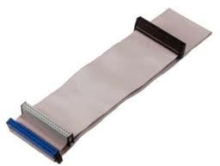 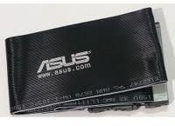

Figure 1. Ribbon cable (40 threads)

Figure 2. Ribbon cable (80 threads)

 When the number of channels is greater than 1, the system is called EIDE (Extended IDE))

Each of the devices on each channel has a role:

* **Master**: The main device (0), which takes precedence over the other in the operating system boot. Besides, it controls de bus
* **Slave**: The second one (1)

 An IDE channel can not be used by two devices simultaneously, so it is preferable that there are no slave devices.

To assign each of these roles, ATA devices have a jumper on the back with a sticker indicating a series of acronyms. The configuration options are:

* **Master/slave** (MA/SL):. Set if the device will act as master or slave.
* **Cable Select** (CS): When both devices are configured in this way the jumpers and the appropriate cable is used, the decision whether master or slave is given by the position occupied by the devices on the cable. Today is the most widely used.
  + 1. IDE Cables

There are different cables IDE connections, either for laptop or desktop. In a laptop there is a lot of variety of kinds, depending on the size of the disk (2.5 '' or 1.8 '') and manufacturer. However, in regard to desktop everything is standard:

* + - * Ribbon cable 40 threads: It has 3 40-pin connectors, one for the controller (motherboard), and two for each of the two devices. Allows speeds up to 33 MB/s
      * Ribbon cable 80 threads: It reaches 44MB/s. There are 80 wires, although the connector has 40, because the 40 extra wires are used as insulation.

 In general, the connectors can go either plate or devices. But the cables labeled as *Cable Select*, clearly indicate connector will connect to *MoBo*, which to the master and which to the slave device.

In addition to the data cable, IDE/PATA devices need a power supply connector (usually called MOLEX)

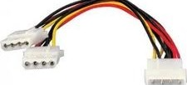

Figure 3. PATA power supply wire

* 1. SATA interface

Transmitting simultaneously relatively large groups of bits, using a relatively large number of wires, it is very useful when we are working with low speeds (that is, few MHz). But at high speeds interferences in the signal begin to show, just because so many connectors in parallel. The solution is usually to minimize the number of cables, isolate and greatly increase the clock speed to compensate. This is the reason why technology moves from a PATA (Parallel ATA) to SATA (Serial ATA).

 SATA reduces 16 bits wide PATA just a bit, but 1.5, 3 or 6 GHz. The transfer speed of this interface is 150 MB/s, 300 MB/s or 600 MB/s, while you maximum of PATA is 133 MB/s1

Unfortunately, there is no clear agreement to call the different variants of the SATA. In the table below you can see some variants with their characteristics:

|  |  |  |
| --- | --- | --- |
| Usual names | Flow rate | Standard |
| SATA, SATA/150, SATA 1,5Gb | 150 MB/s | SATA 1.0 |
| SATA2,SATAII,SATA/300,SATA 3Gb | 300 MB/s | SATA 2.0 |
| SATA3, SATA 6Gb, SATA 6G | 600 MB/s | SATA 3.0 |

Keep in mind that however much we seek SATAIII magnetic hard drives or even SATAII, nowadays a mechanical hard drive barely saturate the SATAI and is not expected to approach or SATAII. That is, the interface is well ahead of internal speeds. Things change when we talk about the SSD.

* + 1. SATA connectors

They are very easy to find because of its L shape. For the data cable pass only 7-wire, 4 to send data and 3 ground. Moreover, the electrical connector has 15 connectors

They have many advantages because they do not block at all air flow, are easier to carry from one point to another of the casing and its length can reach nearly one meter. Besides, theoretically, the disks could be connected with the PC on, though this feature is optional and should check that the disk and the controller supports it.

1 This flow rate is greater than studied in the previous section. It is achieved through the use of technologies of direct memory access

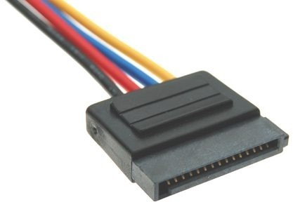

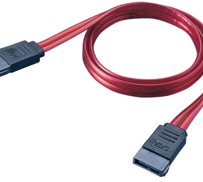Figure 4. SATA power supply wire Figure 5. SATA data cable

* 1. Magnetic hard disks

The magnetic information storage consists in take advantage of the capacity of certain materials to permanently store a given magnetic state that is imposed from outside

The main advantages are:

* The storage is permanent.
* It can be altered any time.
* Its price is very low with respect their capacity. The disadvantages are:
* They are quite delicate. The recorded data may be affected by high and low temperatures, humidity...
* They can be affected by shock
* They can be affected magnetic fields
  + 1. Physical characteristics

The hard disk is a magnetic and mechanical device with moving parts and therefore more sensitive than other systems such as memory. Data is stored in magnetic form on the surface of a series of disks, called platters. These platters are rigid and rotate about a common axis at high speed.

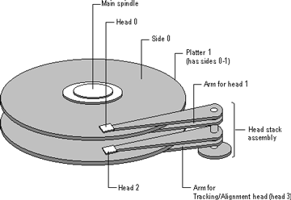To read and write data are available heads. These heads are placed on the platters surface without touching it, floating through the air pressure generated by such high speeds. This lack of contact is what enables high speed read and write and a great capacity of disk. Obviously, the dish surface must be absolutely free of dirt.

The heads are attached to arms which, in turn, are attached to an own axis located next to the

platters, so that the heads can slide radially on

Figure 6. Magnetic hard disk diagram

the surface of the platters.

◻ Keep in mind that there is a head for each of the faces of the plate.

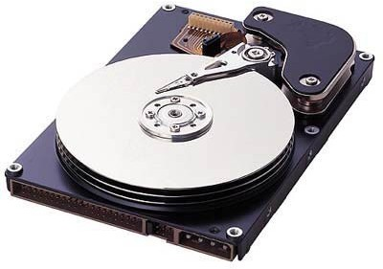

Figure 7. Magnetic hard disk opened

The data is distributed over the platters in thousands of concentric circles called tracks. Each of these tracks is divided into hundreds of adjacent parts of the same capacity called sectors. This capacity is usually 512 Bytes (although nowadays, in modern and high capacity disks, this value is 4096 Bytes) and correspond to the smallest unit of information that can be read and recorded on the disk.

◻ As minimum information unit, we understand that when we send, for example, 200 bytes to write to a hard drive, as the minimum that could save are 512, so 312 bytes are lost. This limitation is even more restrictive when applying the logical layer (that is, when we format the disk).

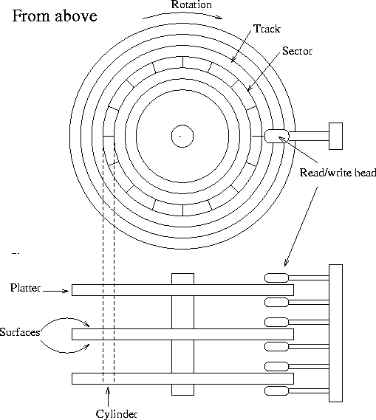

Figure 8. A schematic picture of a hard disk

So that the outer tracks were not underused (the outer tracks are larger than the inside ones and if we divide all the tracks by the same number of sectors, the interior will be more dense and exterior very little used) it is used a different scheme, where tracks are grouped into various concentric zones and each one is divided into a number of sectors greater the greater their circumference.

Finally there are the cylinders. Since the arms of the heads move in unison, on disks with various platters, all heads always be located on the same track number in each. The cylinder is the set of tracks that can be positioned heads in a moment.

 As today heads do not touch the platters, it does not usually have much trouble that these can scratch the platter, but still, occasionally these heads may collide. If a hard drive makes strange noises and starts reading becomes very long it is best to backup critical data and buy another hard drive. Repair a hard drive is an almost impossible or, at least, very expensive task.

* + 1. Addressing mode

Storage protocols have used the *cylinder-head-sector* to locate a data system for a long time. All of them, cylinders, sectors and the faces of the platters (heads) are identified by a number. Knowing these 3 numbers is essential to locate the information. Currently there are disks that can be configured in LBA mode (Logical Block Address) where all disk sectors without consecutively numbered from 0 to n-1.

## MAGNETIC HARD DRIVES FEATURES

* 1. Rotation speed

It is the angular velocity of the rotating platters, measured in revolutions per minute (rpm) and is a key parameter disk performance. Hard drives 3.5'' usually have 7200 rpm. Only low-end or very high capacity has speeds of 5400rpm. In smaller hard drives, the speed is reduced. Thus, in 2.5 '' it is 5400rpm and as 1.8'' 4200rpm.

 The big problem to make disks that rotate rapidly, is the battery consumption that these high speeds need.

* 1. Size of buffer or cache

The buffer is a memory that performs the function of data storage between a "fast" device (disk controller) and a slow (the mechanical part of a hard disk).

This buffer also serves as a disk cache. Thus, when reading data from the processor to the disk requested, may these are already located in the buffer. In this case the data will be read much faster.

The larger the buffer, the more likely that a data was saved on it. Today the tendency is to have 16MB, although there are still 8MB disk and it can be found easily with some 32MB and 64MB.

* 1. SMART technology

Nowadays, a lot of hard disks support SMART technology. This is technology of self-monitoring, analysis and reporting, through which they can come to alert the user to foreseeable problems.

A disk with SMART measures thousands of variables (flight altitude, position of head temperatures, etc.) and compares these values with a number of nominal values and, if the trend seems to lead to a failure, it alerts the user.

## SSD HARD DISKS

The solid state hard drives (SSD) are those that have no moving parts. Since a few years ago here they start to be increasingly implemented

There are two types of SSD's:

* RAM based, for example DDR2. They are the fastest reaching up to 2GB/s per second. Usually they limited by the speed of the interface. Their problem is that they are very expensive and complex to set up. It is also RAM, which require a continuous power supply to maintain the stored data.
* Flash-based (basically the same as a USB flash drive). The most of the SSDs hard' disks work on this technology.
  1. Flash technology

The flash memory is EEPROM2, which has the advantage that your data is not lost when lacking electricity, but it is quite slower than RAM and has a maximum number of writing-readings operations before an error occurs.

The advantages of SSD hard drives are:

* Random access speed. They are more than 10 times faster than magnetic hard drives
* Speed sequential access. Also faster than magnetic hard drives
* Hard drives does not emit any noise.
* They are more resistant to shock and vibration.
* They resist better adverse weather conditions But they have disadvantages too:
* The smallest unit of information to be deleted is 512 kB. Because of this, the system fill free cells before reusing other. When the disk is very full, and is already necessary reuse, it must perform many data movement operations with consequent leak of writing performance.
* Flash memory has a relatively low shelf life (usually around about 10,000 hits) compared to a RAM.
* Today the capacity/price ratio is high although it is expected that over time can lower.

## ADDITIONAL MATERIAL

1. Glossary.
2. Exercises.
3. Questionary.

## BIBLIOGRAPHY

1. Sistemas Informáticos. Isabel Mª Jimenez Cumbreras. Garceta. 2012
2. El PC: hardware y componentes (edición 2012). Juan Enrique Herrerías Rey , Anaya multimedia, 2012

Some pictures are located in:

<http://www.active-undelete.com/hdd_basic.htm> <http://www.tldp.org/LDP/sag/html/hard-disk.html>

2 See unit 2